CDWAI
Community Development Workers Association Inc.

Sogomie Community Begowo, Bena - Goroka Women, with Dove Foundation
New Zealand

“Ecological Agriculture and Adaptation to Climate Change Workshop”

July 2023

Ekolosi Kibung bilong ol Meri
Begowo

CDWAI
PO Box 1032,
Goroka EHP
Papua New Guinea

Funded by: | Dove Trust International - New Zealand
Implementing Agent: | Community Development Workers Association Inc– PNG
Beneficiaries: | Sogomie Fresh Produce Supplier Group, Unggai-Bena District

Venue: | Sogomie Village,
No. of Participants: | 25
Council Ward #: | 1
District: | Unggai - Bena,
Province: | Eastern Highlands Province, PNG
Workshop Facilitators: | David Kulimbao & Anna Kulimbao.
Date of Training: | 20th – 21st July, 2023

Introduction
Workshops are conducted with different groups of participants, mainly with the same topics and sessions. Of course, the main crops and people’s experiences in each location are different so the discussions and points of interest change making each workshop unique, a stand-alone, as will be seen from the participants’ course evaluation comments.

David Kulimbao welcomed participants and opened the training with a word of Prayer.
David introduced the facilitators and named the CDWAI team members in PNG and Overseas.
He described CDWAI’s vision, purpose and reasons for CDWAI inviting the Sogomie people to join in this Workshop. He informed the participants that the training will focus on two areas:
☺ Ecological Agriculture, ☺ Climate Change Adaptation.
The Workshop will take 2 days:
Day 1 will be mainly theory lessons in the meeting room,
Day 2 will be field trip and practical demonstrations in the Kulimbao garden at Glaga.

Day 1 – Session 1 – Discussion and new ideas in the meeting room
All sessions are seminars, kibungs, or 2-way communications in which facilitators ask questions and participants answer with stories of their experiences and their own explanations of what has happened or what they have done.
1) In response to the participants the facilitators put up drawings or illustrations to help with explanations for better understanding. Participants will also produce posters and drawings.
2) Participants, in response, give answers from their observations and community discussions of the impacts on the environment from the changing seasons and climate.

Photographs and Drawings | Comments from Facilitators and Trainees
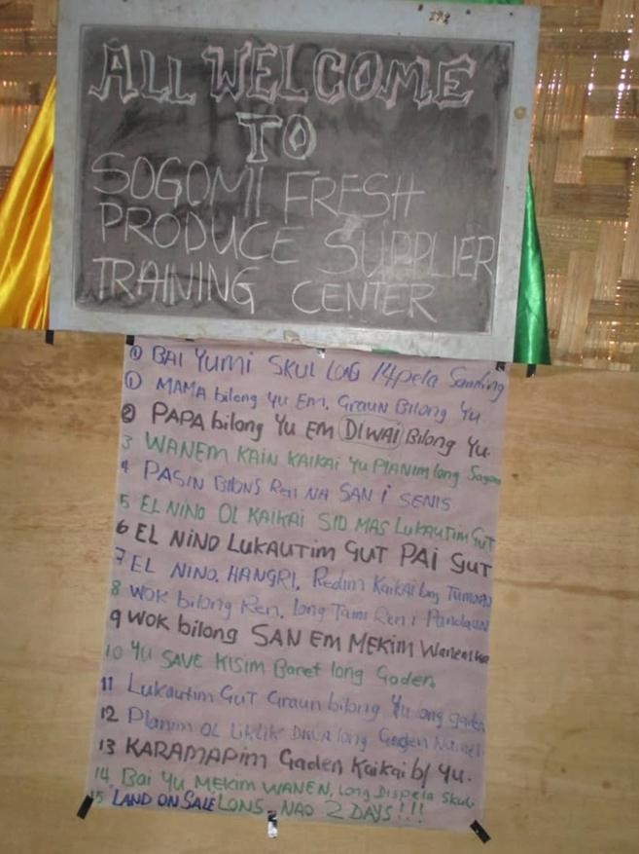 | David drew the attention of the participants to some of the main thoughts, questions and topics and sub-topics that will be covered in the discussions & practical sessions as highlighted opposite.  The Earth is your Mother  The Trees are your Fathers  Look out for and recognize changes in the weather pattern from wet to dry, calm to stormy.  Store dry seeds in case of sudden drought.  What kind of food/crops do we find here in Sogomie?  Playing with fire during drought is longlong bisnis.  Food storage and preservation in case of an El Nino.  What does the rain do when it falls hard?  What does the sun do when it shines hot?  When it rains watch what happens in your garden drains!  How can we look after our land and gardens?  Plant rows of bushes along the sides of garden beds  Build ditch barriers to control erosion of topsoil  Keep dry materials as mulch for the garden.  Mulch protects gardens from heavy rain or fierce sun  What will you do after the training?

Photographs and Drawings | Comments from Facilitators and Trainees
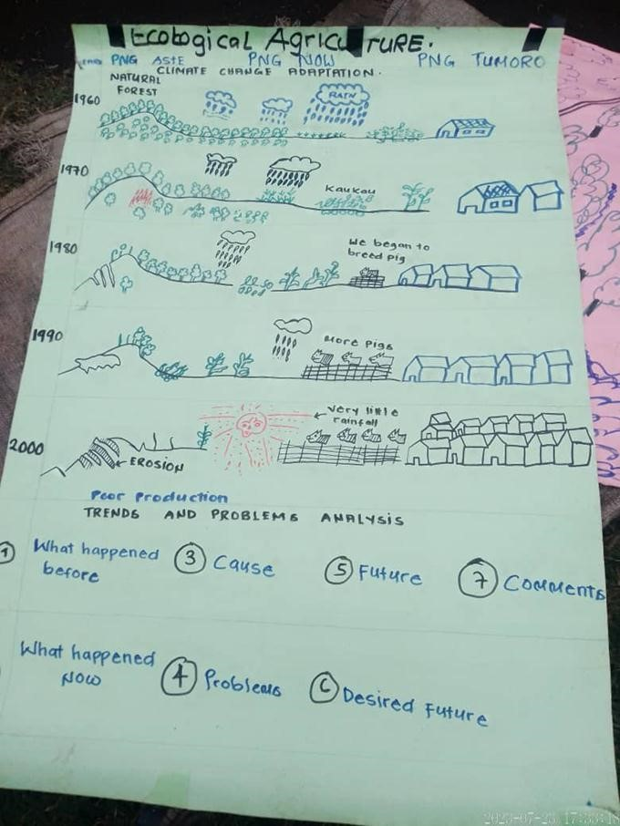 | The facilitators explained the use of our land and forests 70 years ago using the illustration opposite to help the participants understand. It was eye-opening for the participants to realize.  What happened before?  What happens now?  What are the causes?  What are the problems from the cause?  10 years in the future what will their land look like?  What future do you desire for yourselves and children?  What will you do now before it’s too late?  Comments from participants  70 and 50 years ago there was more land, more forests, big bushes, huge trees, more wild animals, many domesticated animals, good rivers/springs, men hunted wild animals using bows and arrows.  There were fewer families and tribe members, lots of various kinds of food to eat, fresh mountain water to drink  Families made smaller gardens, left old gardens for fallow, went to new lands to cultivate.  No axes, bush knives and spades to make big gardens and destroy forests/land. Men and boys live in the Man’s House. Females live in separate houses. Working and assisting each other was very good. People cooperate.  People helped each other in times of need: sharing food, building houses, gardening, bride prices, funeral expense.  Indeed there were tribal wars but not many were killed because they used bows, arrows and spears but today fighting is different. Men are using unlicensed guns.

Photographs and Drawings | Comments from Facilitators and Trainees
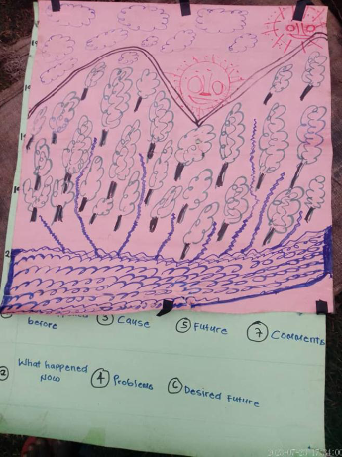 | Answers and Comments from participants  Q. What has happened now in your generation?  - Population is increasing  - There are more Government developments like road, bridges, houses, factories, machinery.  - Big gardens using modern tools, markets everywhere, wild animals disappearing, not enough domestic animals.  - People are burning the bush & the forests. There is soil erosion, landslides, no good mountain drinking water.  Q. From 2011-2023, What are some of the common problems you see in your communities?  - Not enough land, people migrate to towns/ cities  - Family size is booming, not enough household food  - Marriage problems and polygamy  - Lazy people and beggars  - Drug addicts, gambling and drunkeness everywhere  - More people means less food and land to share  - Some families sell their land and migrate to towns looking for a better life  - The land is overused  - Bush burning has led to more kunai grassland  - Top soil is washed away from heavy rain falls  - Small garden, less yields because of less soil fertility  - Our way of gardening is failing, “olpela we i no inap”

Photographs and Drawings | Comments from Facilitators and Trainees
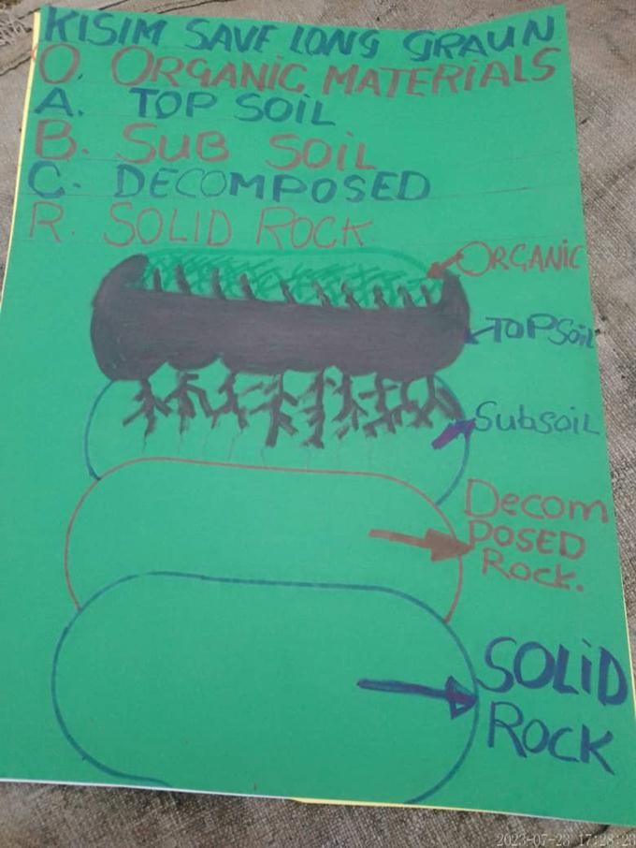 | The facilitators explained the different layers of soil as shown on the drawing opposite  Dead plant and animal materials lie on the top-soil. These dead leaves, rotten sticks/logs, dead animals and other dead materials are rotting down to form a dark, nearly black layer of decomposed organic called the humus.  The humus makes the top-soil below it rich in carbon and other nutrients. We say that it is fertile. The deeper the topsoil the better your garden food crops will grow, if there is enough water!  Down to the sub-soil, there is less humus mixed with it, it is less fertile. If your topsoil is washed away your crops will be poorer.  Below that is the decomposed rock. Sometimes revealing red clay, sands beds or broken rock, which are not good for holding water or gardening. Your crops will dry out in the hot sun when planted.  Coming down to the solid bedrock. It's like a desert. Only a few plants grow very, very slowly on it.  The soil needs improvement.  What can we do to improve our garden soil?  - Apply store fertilizer to make crops grow well  - Apply domestic animal manure/wastes  - Leave the land for some years (fallowing)  - Plant legumes and trees on the land to  - Plant legumes and trees on the land to naturally produce soil fertility for future

Photographs and Drawings | Comments from Facilitators and Trainees
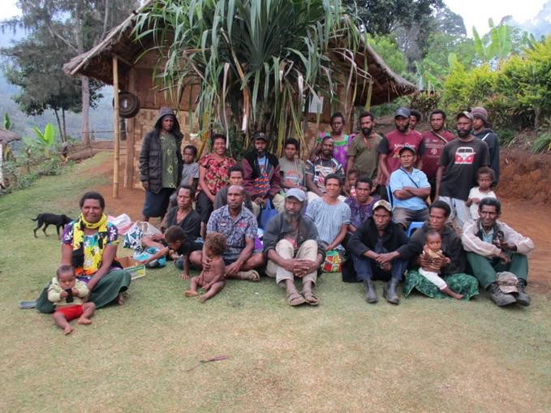  Group photo of the Sogomie training participants | What do you know about Climate Change?  The sun and rain are out of balance.  The weather goes ‘longlong’/crazy.  - Heat from the sun is very hot.  - Food crops are burnt up in the gardens.  - Increase in pests (weevil) in the gardens.  - Food production is very low.  - Low level of big rivers. Small rivers and springs dry up.  - Very heavy rain in some places yet very dry elsewhere  - High frequency of water related diseases from drinking polluted rivers/springs.  - Shortage of food.  - People are sick and dying.  - Pollution (smoke and gas/ CO2) from big factories around the world goes up into our atmosphere like a blanket trapping the heat of the sun. This creates drought/ taim drai/ El Nino, the Baby.  - When this happens other parts of the world experience heavy rainfall causing landslides, floods destroying farms, roads, bridges. People are drowning in the countryside, cities and towns. This is called La Nina, the Mother.  - When we experience very hot sun or drought it may start El Nino, the Baby, destroying forests, water holes/springs, food gardens and bringing pests, diseases, hunger, bush fires and more deaths.

Photographs and Drawings | Comments from Facilitators and Trainees
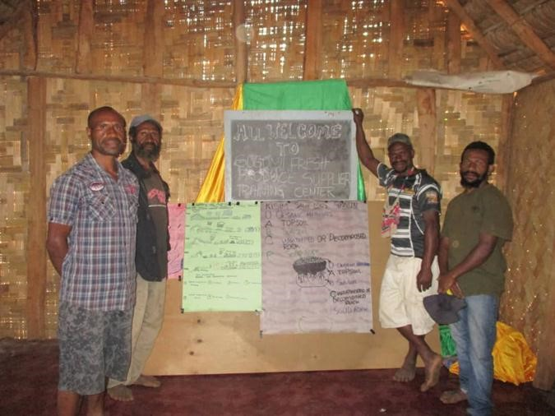 | Participants become Trainers  Before winding up the classroom theory lessons the facilitators asked 4 participants to explain the 50-year timeline and the different layers of soil.  The men helped each other to recall the day’s discussions very well, like the Trainers.  Comments  This shows that the men and the rest of the participants understood what was taught.
Toksave for Day 2
Participants were asked to meet at David and Anna Kulimbao’s block the next day for their Field Day, demonstration and practical work

Day 2 – Demonstration and Practical lessons
Continuation of the session about Climate Change and Adaptation.
Yesterday we discussed “What is climate change?”
Today we start with the question: “What is adaptation?”
Photographs and Drawings | Comments from Facilitators and Trainees
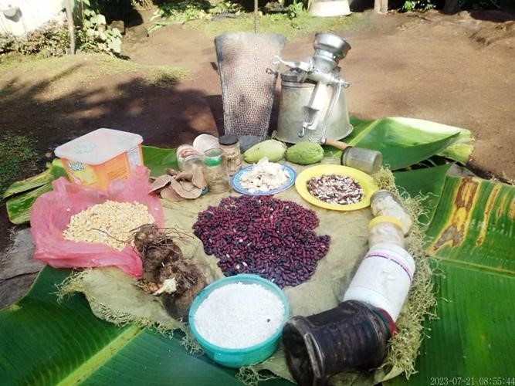 | What do you know about Adaptation to Climate Change?  Adaptation is your ways of making changes to look after your gardens during the droughts of El-Nino or the big rains of La Nina.  The facilitators Anna and David took turns in sharing experiences of storing food and seeds in the case of an emergency like the El Nino or a natural disaster. Both of them displayed dried seeds and preserved food stored in containers as examples for the participants to do the same in the case of a severe drought and explained:  - Many different garden seeds can be dried in the sun or kitchen house and stored for future use.  - You can cook some of the dry seeds during drought. Soak them in water overnight then cook as usual the next day  - Seeds like peanuts and some beans will store well.  - Cassava can be ground up or cut into small pieces and boiled, then dried and stored in bags for several months.  - When you need to use the cassava flour soak it overnight, mix with wheat flour then fry like flour-balls for the family.  - Place dried seeds in containers and or bags away from rats and pests. Some possible ways were discussed with inputs from the trainees.  - Storage containers must be very dry inside and not wet or moisture before storing seeds. Otherwise, you spoil all the seedlings.

Photographs and Drawings | Comments from Facilitators and Trainees
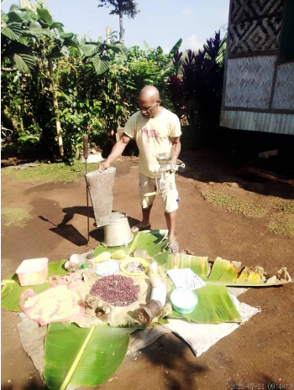 | Day 2 Adaptation Seed Storage lesson continued  David showed the participants a hand grinder sold by Brian Bell Home Centre. This can be purchased to grind cassava for drying then storing for future use.  Other dried seeds like corn can also be ground and the flour cooked by itself or mixed with wheat flour to cook for the family.  Drought Resistant Crops  Facilitators also showed examples of drought resistant crops like Cassava, African Yam, Taipa banana, Taro Kongkong (Singapore Taro), and Lima Beans  - Plant a lot of African yams. Regardless of the drought. Yams can resist the heat from the sun and provide food for your family.  - You must plant a lot of cassava along the drains as hedgerows for alley cropping. The surplus, too much to eat, can be dried and stored for future use.  - Plant a lot of African yams. Regardless of the drought. Yams can resist the heat from the sun and provide food for your family.  - Taro kongkong can grow anywhere so plant a lot in the case of emergency use.  - Plant other locally known drought resistant crops in your gardens.  - Remember to plant long-lived crops as well as the food crops that give you short term yield.  Trainees' responses from the seeds display:  “We only stored just enough dry seeds for planting. It's a new idea. We will try to store enough for planting and eating in the case of emergency.  However, some of us know how to dry cassava. Other do not have any clue about processing and storage. Maybe you could give us training on that”.
Photographs and Drawings | Comments from Facilitators and Trainees
Field Day  Trainer David shows participants the top soil where the dead decomposed materials formed the humus as illustrated on butcher’s paper in the classroom yesterday.  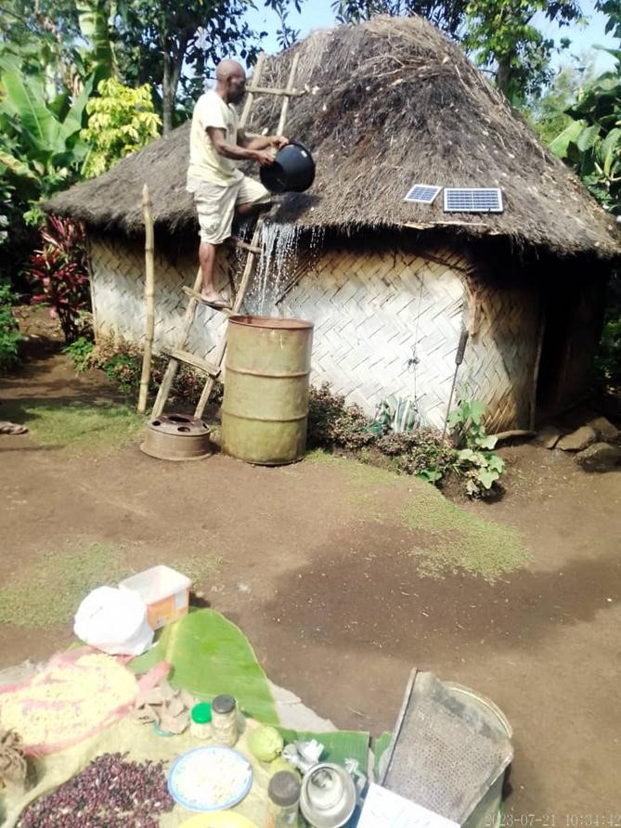 | Field Day at Kulimbao’s  Trainer David told the participants to prepare in advance to put out a possible house fire during drought or any other time:  Use matches sensibly, not for play. Fire can destroy a forest, grassland or even your house during dry spells.  To stop or put out a possible fire you must have the following ready to fight fire:  - Have a stand by ladder to climb ono the roof to put out a house fire.  - Have a 200 litre drum of rain water close to the house to stop a fire.  - A bucket must be on hand to fetch water from the drum to pour on the fire to quench it.  - Without these tools, your house, including your possessions, will be gone in minutes after you labored for several weeks or months to build it.  - Tell your community leaders or you carry out awareness in your village to convince people to stop making careless fires. This will protect the forests, grassland and houses.  - Help your community or village to draw up and agree upon a Fire Management Agreement.  - Only fires for gardens. No random fires.  Field Day  Trainer David shows participants where the dead decomposed materials form humus lying above the topsoil as illustrated on butcher’s paper in the classroom yesterday.

Photographs and Drawings | Comments from Facilitators and Trainees
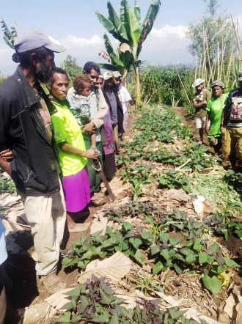 | David Kulimbao showed participants a sweet potato plot with mulch. Anna explains the reasons for mulching a garden.  - Stops rain from washing away the top soil.  - Keeps the soil moist.  - Hold the nutrients back in the soil.  - Stop weeds from growing.  - Prevents the loose soil from eroding when rain falls in your garden.  Comparison between a bare kaukau mound and a mulched kaukau mound  Anna showed which mounds erode faster when water is poured on them. She demonstrated with a watering can:  - Bare kaukau mound – when Anna poured water on the mound the water quickly washed soil away into the drain.  - Mulched kaukau mound – less or no soil eroded away when Anna poured water on the mound.  Participants agreed that mulching was a very good way of protecting the soil from erosion.  David also emphasized throwing rubbish and food scraps from the kitchen into their backyard gardens. Scraps will decay and provide nutrients for the food lants to grow well. Or feed the scraps to the pigs then shovel the manure onto your gardens.

Photographs and Drawings | Comments from Facilitators and Trainees
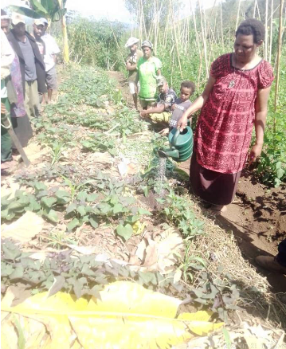 | Field Day  Anna demonstrates to the group watering their food crops during dry spells, drought or an El-Nino.  She further explained that:  In drought if you don’t water your garden, you won’t have food.  During droughts, you must water at least 20 kaukau mounds to keep them alive. But 200 mounds will be too much work, It would kill you  Plant some vegetables (Chinese cabbage) close to river beds or your backyard to water.  Don’t plant gardens away from river beds. There may be no water to water your gardens.  Share your land along river beds to help your neighbours during critical times like an El Nino.  Those who own pieces of land along river beds must always try to share land and water.
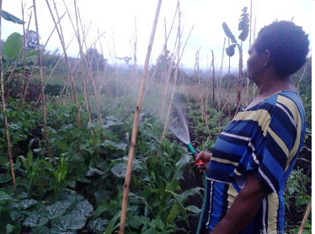 | Anna showed participants how they could water kitchen or backyard gardens around their house in their village. Several families can bring water from a creek with black poly and white PVC pipe then use rubber garden hoses to water.

Photographs and Drawings | Comments from Facilitators and Trainees
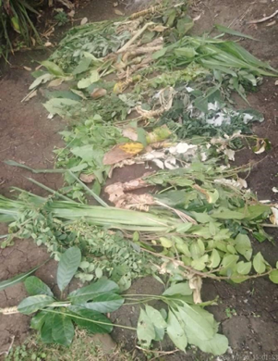 | Some small plants, including local legumes, uprooted from the area are displayed here on the floor for participants to see.  As well they showed the participants small barriers in the barets between garden beds to stop soil washing away when the rains come.  At their next garden they showed how:  1) Rows of plants along the edges of garden beds, hedgerows, can stop soil erosion  2) You can slash chest high hedgerows for mulch to rot down into the topsoil  3) Alley cropping between the hedgerows holds back the soil from washing away  4) Ditch barriers in the barets stops soil washing away down the drains.  David and Anna also mentioned names of other garden plants or crops that can be planted along drains and across sloping gardens to stop erosion and even feed to goats or rabbits:

Photographs and Drawings | Comments from Facilitators and Trainees
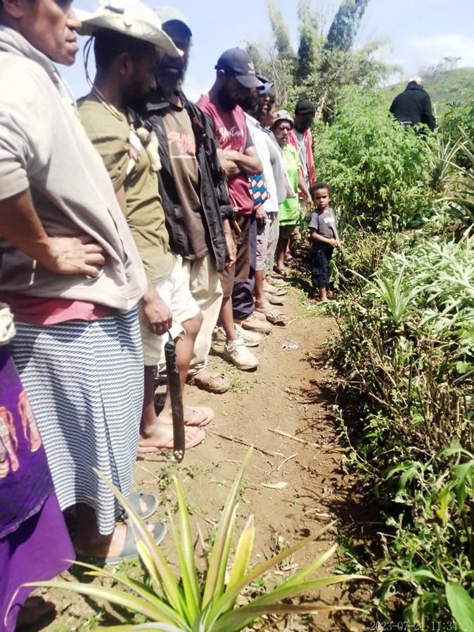 | Field Day  David and Anna walked the trainees to their next garden where they were shown:  ♣ Hedge rows, alley cropping and ditch barriers where the Kulimbaos use local plants and food plants planted to stop soil erosion.  ♣ Participants were shown banana stalks and other materials staked in the main drains to hold back eroded soil for shovelling back onto their garden beds.  Participants commented  Unfortunately and carelessly we have lost so much good soil and never cared for our land. Thank you for teaching us new skills. We will try to implement some of these skills in our gardening system when we go back home.
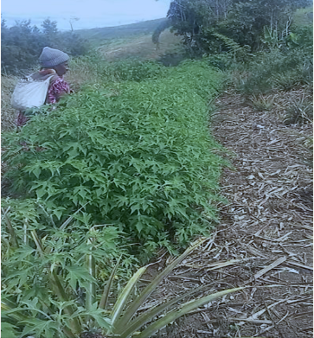 | David and Anna showed the participants many rows of Wild Sunflower and shrub legumes like Tephrosia in the photo opposite.  These shrubs can be planted as hedgerows along the edges of the garden beds separating one crop from another. When they grow to chest height you cut them into pieces for and placing in the garden as mulch and digging into mounds for compost.  Beans, peanuts, 7-year bean and soybeans are also legumes like Tephrosia, Pigin Pea and Flemingia. All legumes have a poroman bacteria in little balls on their roots.  If the poroman balls have red blood inside them they are taking nitrogen from the air. The bacteria fix that nitrogen to make fertilizer for themselves and the legume they are living on. So legumes add nitrogen fertilizer to your gardens.  That means that when you harvest your peanuts or soybeans cut the nuts or soybeans off leaving as many roots in the soil as you can.

Last Thoughts – Pasim Tok
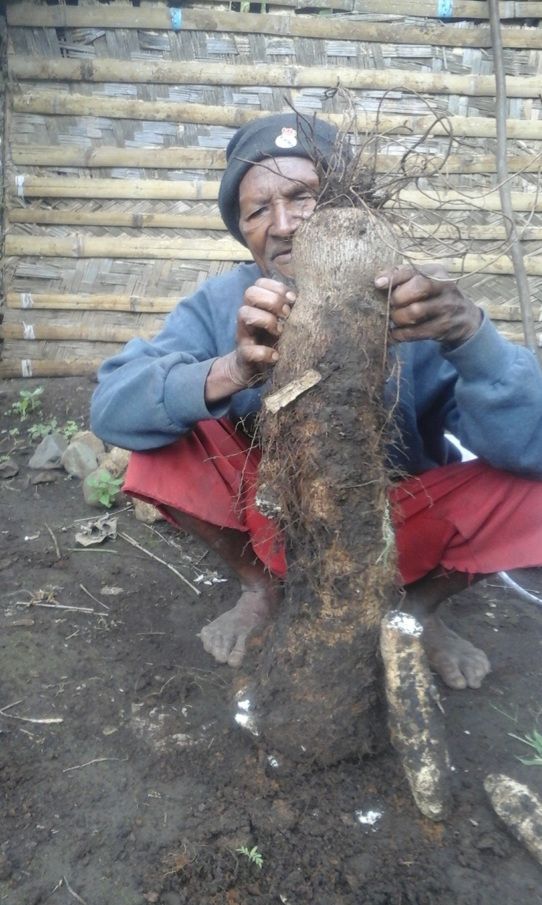  Grandfather Yoko Kulimbao with his African Yam | David and Anna ended the Ecological Agriculture - Climate Change Adaptation Workshop with the following reminders before going onto Evaluation.  We need to prepare in advance for severe rainstorm events, sudden dry spells or long El-Nino droughts.  - Since 1990 and especially 1997 we have seen the seasonal weather pattern change.  - Remember, the weather can change anytime!  - During drought there will be more pests in the gardens and in your houses. Rats and mice will hunt your seed and taros under the ground  - Trap the rats. Make sprays to kill the caterpillars. Plant safe-home bushes for the caterpillar hunters.  - Prepare safe containers and places for all your different food seeds!  - After the drought the crops will be all green leaves so plant beans and corn  - Prepare safe containers and places for all your different food seeds!  - After the drought the crops will be all green leaves so plant beans and corn  - Take care to wash! Lack of water for washing will cause all sorts of diseases to affect humans and animals  - Remember, the land is your Mother. The trees are your Fathers.  - Prepare gardens for the different food crops you must plant to secure your family food in drought.  - Fire is for the house and for making gardens. Or else it is a forest demon ruining your land. Matches are a tool, not a toy for longlong people.  - Look after your water, rivers and springs  - Look after your land to care for your gardens  - Do you know when an El Nino will come? Are you ready to save your family from taim hangri?  - Remember the 4 layers of the soil. Which layers are the best for planting/gardening?  - Are you like others going to sell your land with your mobile number on the notice board for buyers to ring you?

Workshop Evaluation
What do you think about the training? Is it helpful or not helpful? Give us your comments!
Mr Foster – “Ever since, I have never received training like this to care for the land, forest and gardens and manage soil. Also to prepare for drought is another thing which I treated as normal but now I know to take action. The training is helpful. We need to go home and care for our land.”
Mrs Golina Les – “I’m truly challenged about not caring for my land, planting trees to replace the trees cut down, managing drains, erosions and playing with fire. I will also dry enough seeds to store for later use. When I return home, I will get my family to care for the land and gardens”.
Mr Allan – “Drainage controls water flows from the rain but now I discovered from this training that soil is also running away in the drain. I need to do something to recapture this soil and put it back into my
Mrs Neku – “I’m quite happy to learn about new skills of gardening and caring for our land. I used to burn dry grass in my garden to prepare for planting but now it is different. I will plant crops and use the dry material as mulch to cover my crops. I see mulching has many good advantages”.
Mrs Stena– “I’m very thrilled about storing enough food and seedlings for planting and later use. I used to dry a few corn cobs, peanut and bean seeds but now I should store more seeds. This will assist my family in critical times like we discussed”.
Mrs Rose – “When I was a little girl, we had big forests, fertile land, food production was very big, water level was high. As I grow old, married and have children; the environment has diminished. My heart is rejoicing because the training skills acquired today will be implemented by my family. I will take the lead. Thank you for teaching us”.
Mrs Anita – “I have listened and seen what you did about planting small plants to stop erosion, mulch to protect food crops is something new to me. Your talk about the 4 layers of soil and the topsoil containing decomposed materials is also new to me. This kind of training costs money to attend but you have given us freely. I’m so thankful for that with your team. God bless!”.
Mr Lesley – “I’m one of those who put up notices to sell my land. Your teaching really caught me. I’m truly embarrassed. Everything we acquire from the training is true. I will encourage my family to change our attitudes towards caring for our land, for forest, water and gardens”.
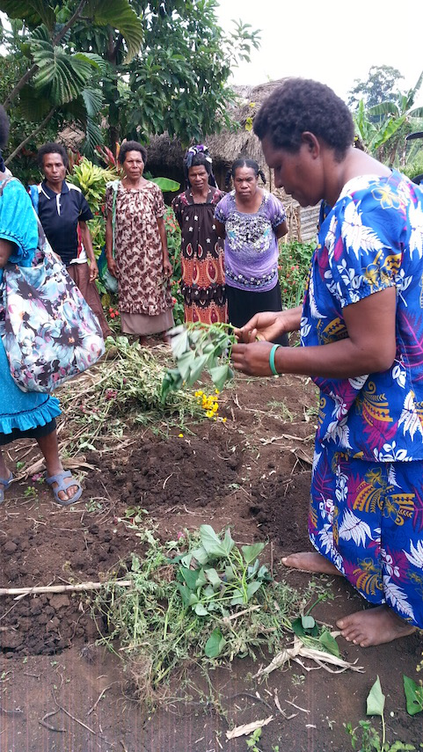
Anna Kulimbao demonstrating new ways of selecting and planting sweet potato runners to avoid kaukau gall mite and kaukau weevil.

Names of Workshop Participants from the Sogomie Fresh Produce Supplier Group
No. | Name | Male / Female | Village
1 | SEMETY | Male | Sogomie
2 | PILOE | Male | Sogomie
3 | ESSA | Male | Sogomie
4 | STENA | Male | Sogomie
5 | ALLAN | Male | Sogomie
6 | NOVI | Male | Sogomie
7 | ARO | Male | Sogomie
8 | OPOE | Male | Sogomie
9 | TUA | Male | Sogomie
10 | SAKA | Male | Sogomie
11 | FOSTER | Male | Sogomie
12 | GOMEX | Male | Sogomie
13 | LESLEY | Male | Sogomie
14 | ROBERT | Male | Sogomie
15 | TIKU | Male | Sogomie
16 | SENI | Female | Sogomie
17 | NEKU | Female | Sogomie
18 | ROSE | Female | Sogomie
19 | AULESI | Female | Sogomie
20 | ANITA | Female | Sogomie
21 | GAWI | Female | Sogomie
22 | GOLINE | Female | Sogomie
24 | BUN | Female | Sogomie
25 | AFAYE | Female | Sogomie
End of training report – compiled by Peter Taul and Ben Heyward

